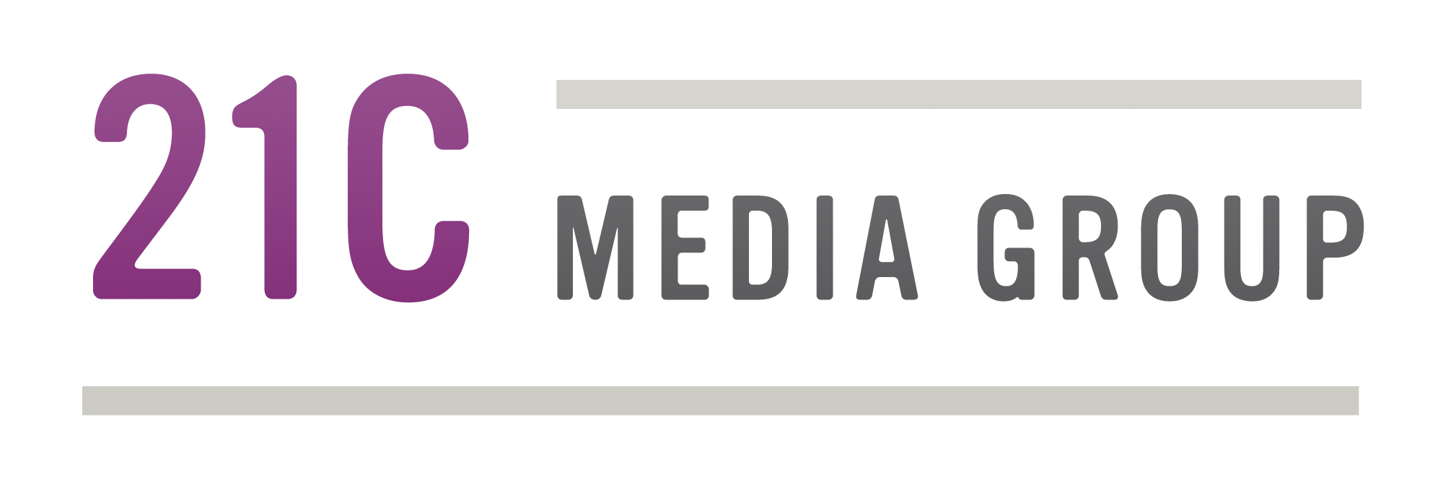
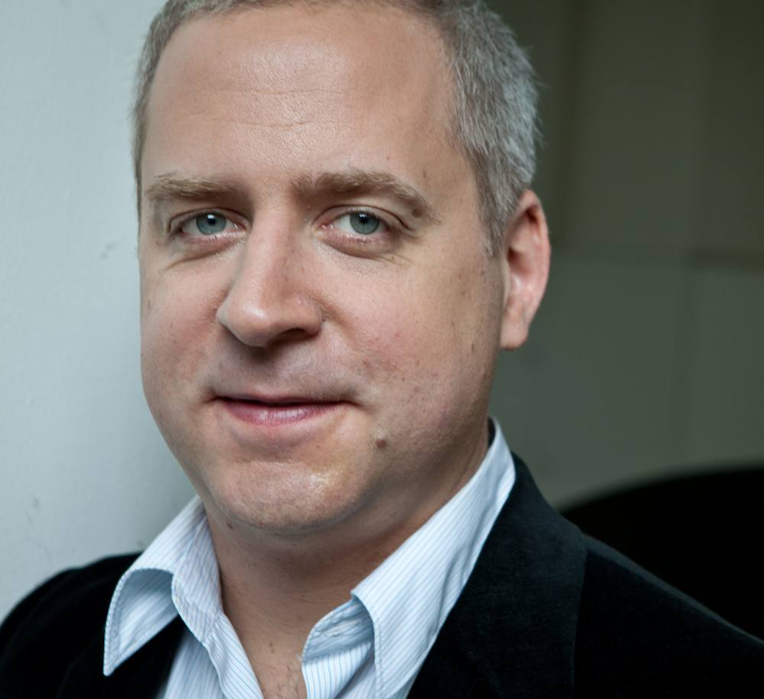
JEREMY DENK
Pianist; winner of 2013 MacArthur “Genius” Grant
at a glance

One of America’s most thought-provoking, multi-faceted, and compelling artists, pianist Jeremy Denk is the winner of a 2013 MacArthur Fellowship, the 2014 Avery Fisher Prize, and Musical America’s 2014 Instrumentalist of the Year award. He has appeared as soloist with the Los Angeles Philharmonic, the Philadelphia Orchestra, and the symphony orchestras of Boston, Chicago, San Francisco, and London, and regularly gives recitals in New York, Washington, Boston, Philadelphia, and throughout the United States. Next season, he starts his three-year tenure as Artistic Partner of the Saint Paul Chamber Orchestra and makes debuts with the Cleveland Orchestra and the New York Philharmonic. Denk is also known for his witty and personal writing; his blog, Think Denk, is widely read and enjoyed both within and outside the industry, and he has written pieces for the New Yorker, the New York Times Review of Books, Newsweek, the New Republic, and the website of NPR Music. One of his New Yorker contributions, “Every Good Boy Does Fine,” will be the basis of a book he is writing for publication by Random House in a couple of years’ time. He will be Music Director of the 2014 Ojai Music Festival, where as well as performing and curating he is composing the libretto for a semi-satirical opera. His debut recording for Nonesuch Records presented music by Ligeti and Beethoven and was included on many “Best of 2012” lists, including those of the New Yorker, Washington Post and NPR Music; his second recording for the label – of Bach’s Goldberg Variations – reached number one on Billboard’s “Classical Albums” chart and was named one of the “Best of 2013” by the New Yorker and the New York Times.

Biographical info:
- Born: May 16, 1970 in Durham, North Carolina
- Studies: Oberlin (double degree in Chemistry & Piano Performance), Indiana Univ. and Juilliard
- Lives in New York, NY
Some highlights of 2013-14 season:
- Aug 2013: Australian debut, playing Brahms’s Piano Quintet on nine-date national tour with four principal members of Australian Chamber Orchestra
- Sept 2013: Nonesuch Records releases Bach’s Goldberg Variations (Sept 30), plus performances in Boston, Chicago, & Washington DC. A companion DVD offers video “liner notes” in which he explains/demonstrates features of the work from the keyboard (see excerpt here)
- Nov 2013: joins San Francisco Symphony and Michael Tilson Thomas for Mozart’s Piano Concerto No. 25, in orchestra’s home at Davies Hall and at Carnegie Hall
- June 2014: serves as music director of 68th season of Ojai Music Festival. One highlight: world premiere of new opera co-commissioned by Ojai, Cal Performances at Berkeley, Carnegie Hall and Aspen Music Festival, The Classical Style: An Opera (of Sorts), with music by Steven Stucky and libretto by Denk himself (Denk describes it as “a love letter to Mozart, Haydn and Beethoven … A satire of classical pomp”).

Links to some of his writings:
- The Guardian, Nov 8, 2013: Bach’s Goldberg Variations caused me misery – But I still can’t get enough
- New Yorker, Oct 14, 2013: shares a story from his early career in Piano Man. Also discusses this in New Yorker podcast Out Loud: The Trouble With Bach
- New Yorker, April 8, 2013: a personal history: Every Good Boy Does Fine: A life in piano lessons
- Review of Paul Elie's Reinventing Bach in The New Republic, Nov 12, 2012
- Review of Krause's The Great Animal Orchestra in New York Times Book Review, April 2012
- Account of making a recording in The New Yorker: Flight of the Concord

Media recognition:
- Profile on PBS’s NewsHour, Dec 2013 Jeremy Denk on the weirdness of great music
- Profile in April, 2013 Issue of Vanity Fair
- Profiled by WNET’s NYC Arts, May 2012
- Interviewed on NPR’s Fresh Air, May 2012
- Feature by Denk about recording Ives in New Yorker, Feb 2012
- Major profiles in Wall Street Journal and New York Times

Recording activities:
- Sept 30, 2013: Bach’s Goldberg Variations for Nonesuch Records
- May 2012: debut recording for Nonesuch Records, Ligeti/Beethoven
- Jan 2012: collaborative recording with Joshua Bell, French Impressions, on Sony Classical
- Oct 2010: 1st solo recording, Jeremy Denk Plays Ives, incl. Piano Sonatas 1 & 2 (Concord)

Think Denk:
His weblog, “Think Denk”, is mixture of musical and extra-musical observations, often pertaining to nothing in particular. Alex Ross, New Yorker’s music critic, wrote of it: "Besides being a brilliant musician, Denk is simply one of the most interesting writers I know."

Interesting facts:
- Made NY recital debut at Alice Tully Hall in 1997 as winner of Juilliard Piano Debut Award
- Met violinist Joshua Bell in 2004 at Spoleto Festival; their musical partnership, beginning with a 2005 tour, continues to this day
- Made solo recital debut at Carnegie Hall in March 2011 substituting for ailing Maurizio Pollini, and returned to the main stage there in March 2013 for another solo recital.
- Taught at Indiana Univ. School of Music, 1996 to 2002; currently on faculty of Bard College
- Received a double degree in Chemistry and Piano Performance at Oberlin College
- Deep commitment to music of Charles Ives; has paired Ives’s Concord Sonata with Beethoven’s “Hammerklavier”. Denk explains: “People ask me after concerts why I perform Ives—why I’m drawn to him—and the answer proves difficult to communicate at your average cocktail party. It’s because the music is brilliant, inventive, tender, edgy, wild, original, witty, haunting.”

Awards:
- 2014 Avery Fisher Prize
- 2013 MacArthur Fellow (“genius grant”)
- Musical America’s 2013 Instrumentalist of the Year
- 1998: won Young Concert Artists International Auditions and Avery Fisher Career Grant

Audio & video:

MacArthur Fellow video Video here

http://jeremydenk.net/listen.php
- In Practice NPR - video/interview (June 2012) Video Here
- Profile WNYC NYC-ARTS (May 2012) Video Here

Critical acclaim:
- “Of all America's up-and-coming classical instrumentalists, Jeremy Denk, the pianist-blogger…, might well be the most interesting.” — Wall Street Journal
- “Mr. Denk…is regarded as one of his generation’s most eloquent and thoughtful interpreters.”
— New York Times
- “Denk, whose witty, self-deprecating blog draws almost as much attention as his playing, is an omnivorous musician, who scales the Everests of the solo literature … His performance was a tour-de-force of concentration and keyboard command.” — Washington Post
- [Re. Ives’s “Concord” Sonata and Beethoven’s “Hammerklavier” Sonata] “The real argument for the linkage between these pieces came with Mr. Denk’s thrilling performances. He played these daunting scores … from memory, bringing a rare combination of command and spontaneity to his dynamic performances.” — New York Times
- “As [his] career has blossomed in recent years, his public artistic identity — his “brand” as a performer — has been unusually shaped by a kind of secret weapon: his gifts as a writer.” — Boston Globe
- “A rendition of Bach’s ‘Goldberg’ Variations … was entrancing from the first notes of the famous Aria, a magical experience that was one of the best solo performances this year.” — New York Times
- “[At] his Zankel Hall recital début … he will play one of the most demanding recital programs in recent memory: the “Hammerklavier” and Charles Ives’s no less monumental “Concord” Sonata. Prior concerts have suggested that Denk has the chops, the brains, and the heart to pull it off.” — New Yorker
- “Denk … — who also happens to have a background in chemistry and who also happens to be a gifted writer (his blog, Think Denk, is marvelous) with a deep and original musical mind — was another hero of the festival. If he had done nothing more than rescue Ives’ First Piano Sonata from obscurity, which he did in his glorious Saturday morning recital, I would say the weekend would have been worthwhile.” — Los Angeles Times

Engagements spring/summer 2014:
March 30 13th Annual Robert E. Turner Piano Recital Santa Monica, CA
April 4 & 6 Tucson Symphony Orchestra Tucson, AZ
April 12 Peoples’ Symphony Concerts (recital) New York, NY
April 15 Sewanee: The University of the South Sewanee, TN
April 18 & 19 Nashville Symphony Orchestra Nashville, TN
April 26 Tisch Center/92nd St Y, with Steven Isserlis, cello New York, NY
April 30; May 1-3 Recital; São Paulo Symphony São Paulo, Brazil
May 17, 18 Los Angeles Chamber Orch/ Jeffrey Kahane Glendale, CA
May 24 Barbican Hall/LSO St. Lukes London, UK
June 12-15 Music Director, 68th Ojai Music Festival Ojai, CA
June 16-21 Cal Performances, 4th Ojai North! Berkeley, CA

www.jeremydenk.net

www.facebook.com/JeremDenkOfficial

www.twitter.com/jeremydenk

